Comparative adjectives

Grade 3 Adjectives Worksheet

Complete the chart.

Normal Adjective | Comparative | Superlative
slow | slower | slowest
 | faster
 |  | quickest
 | later
sad
 |  | prettiest
calm
 | happier
 |  | cleanest
dark

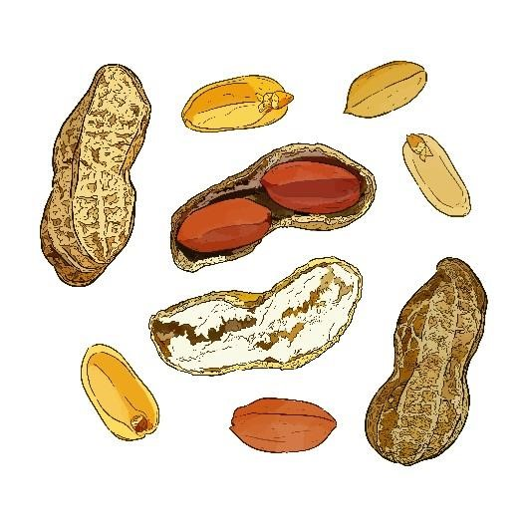
Is the underlined word a normal adjective (“N”), comparative (“C”) or superlative (“S”)?

____S____1. Mary is the wisest girl I know.
_________2. Karl is tall for his age.
_________3. James is lazier than Robert.
_________4. Peanuts are cheaper than cashews.
_________5. The closet is the fullest it’s ever been.

