Name: ___________________________

Subtract.

**a.**

3

7

1

**b.**

9

5

2

-

2

4

5

-

1

0

9

**c.**

2

0

6

-

4

1

**d.**

8

7

3

**e.**

4

7

5

-

4

3

9

-

2

5

8

Re-write the problems vertically, then solve.

**f.**

223 -

127 = _______

**g.**

889 -

60 = _______

**h.**

61 = ______

115 -

**i.**

To celebrate Earth Day, Mr. Johnson's class

is planting small trees in a nearby park.

The girls planted 102 trees. The boys

planted 81. How many more trees did

the girls plant?

answer: _____________

Remember to show your work and label your answer.

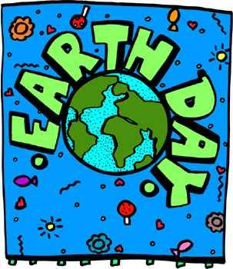

***Super Teacher Worksheets -*** [***http://www.superteacherworksheets.com***](http://www.superteacherworksheets.com/)