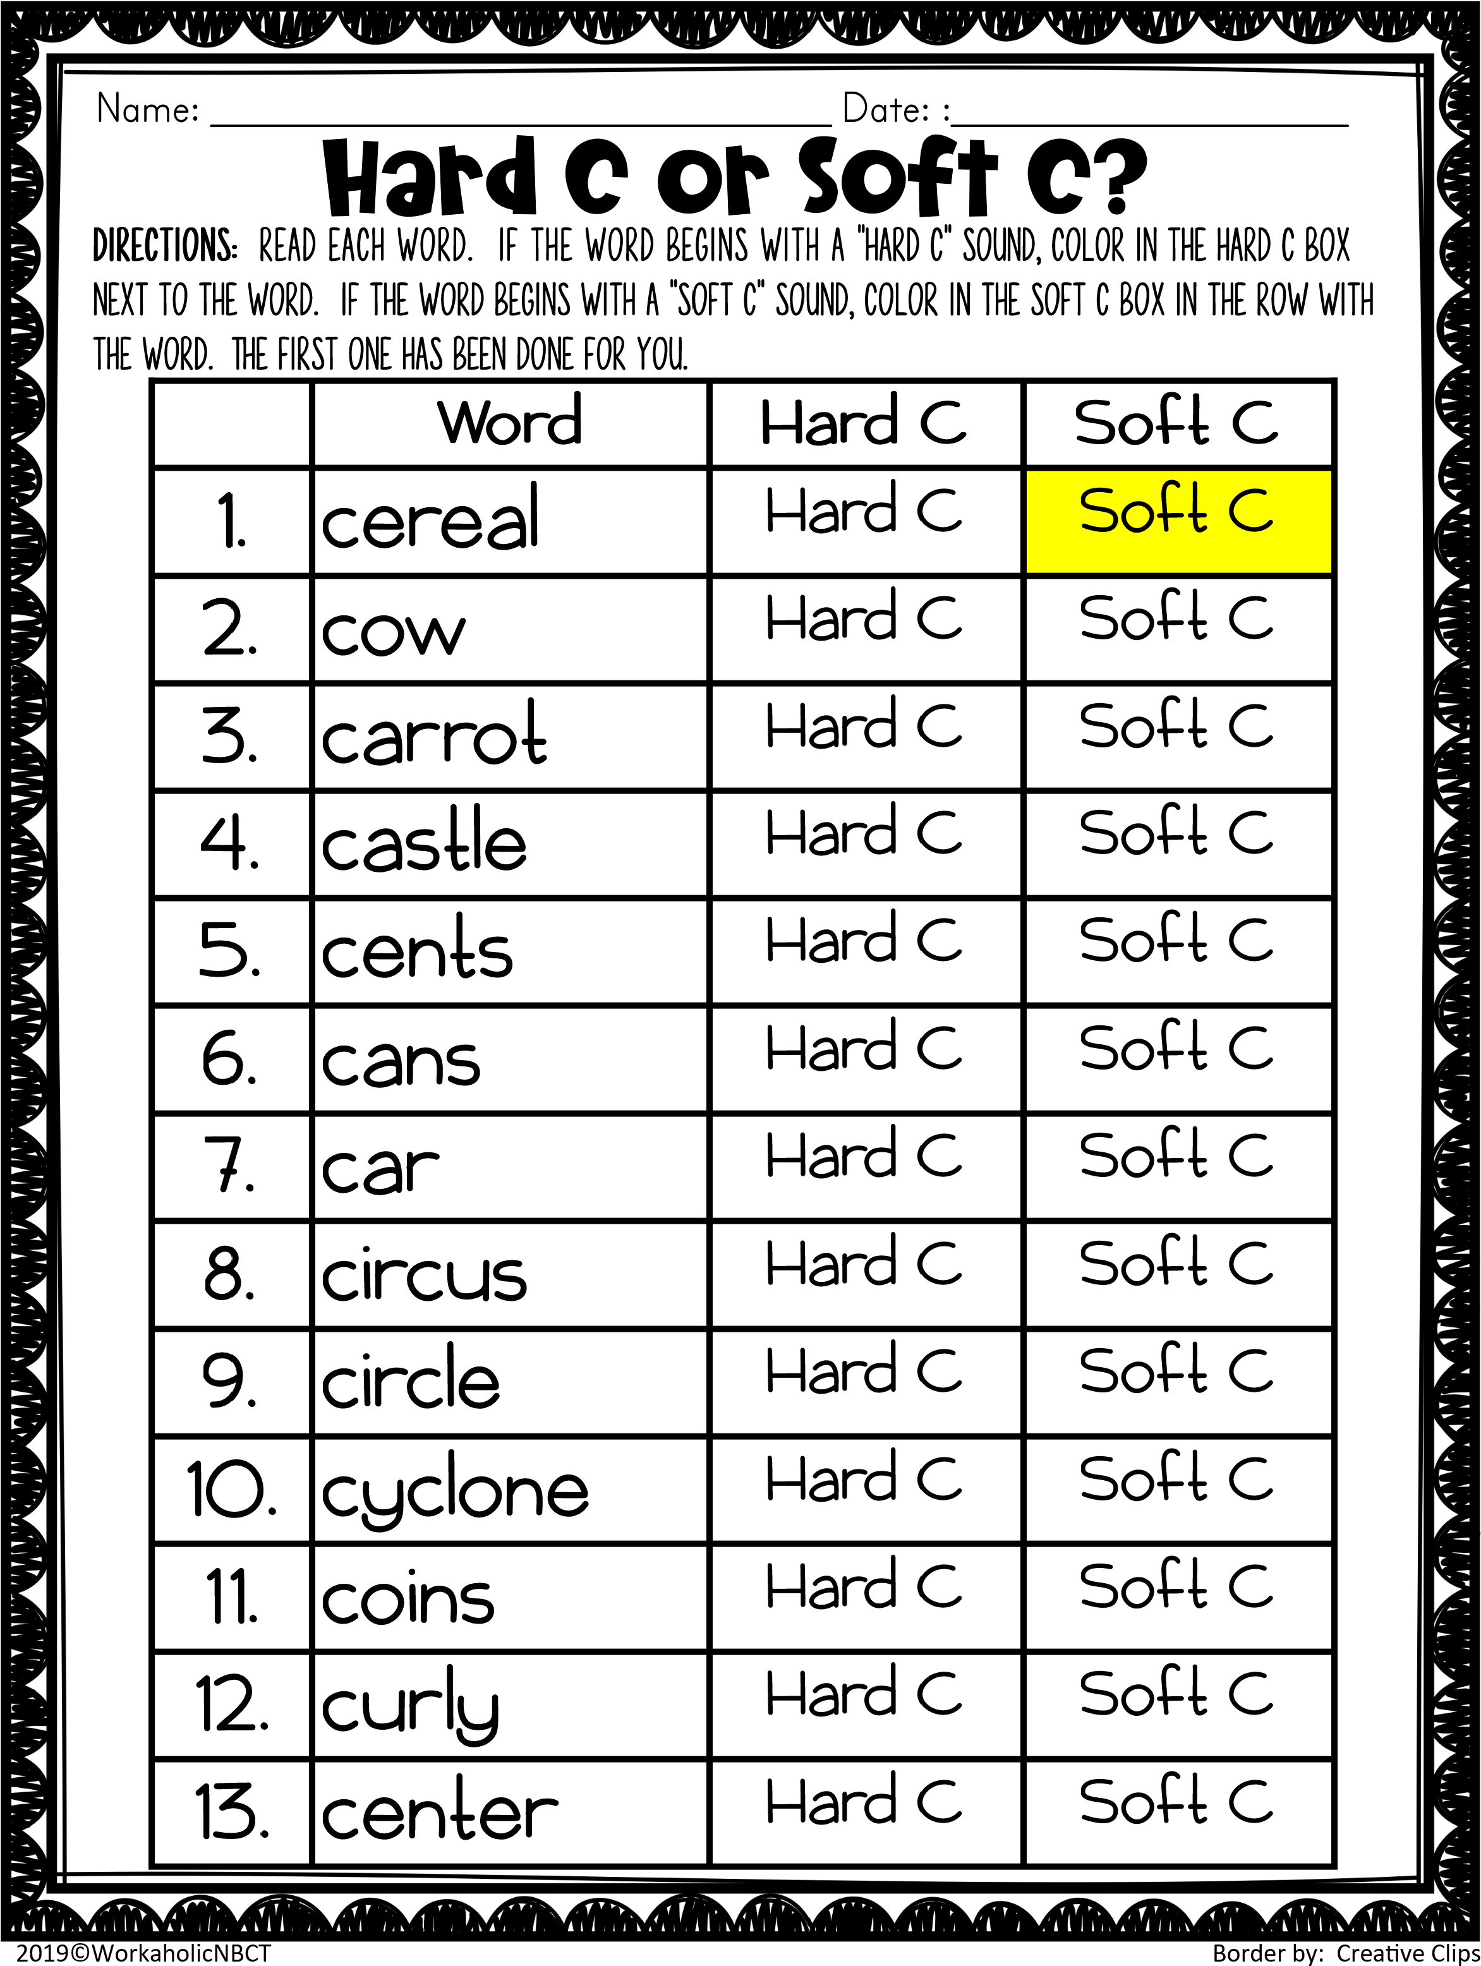

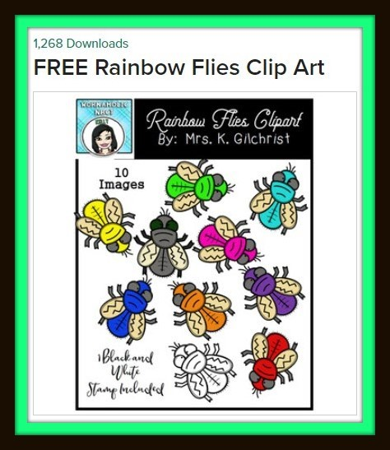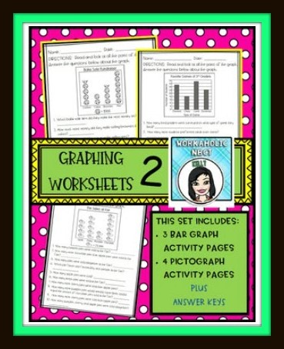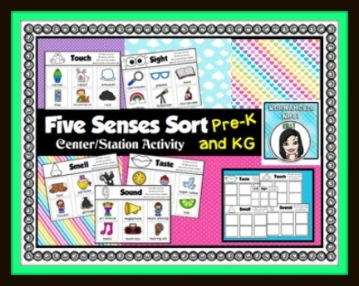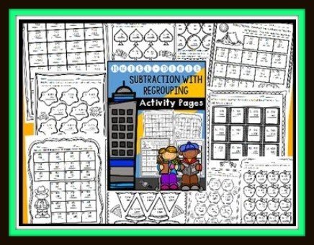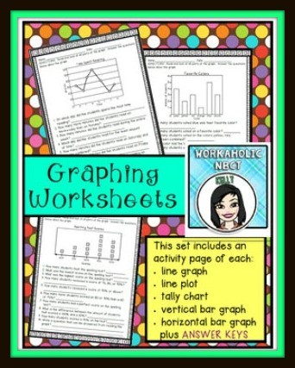

[•](https://www.teacherspayteachers.com/Product/Graphing-Worksheet-Pages-bar-graphs-line-graphs-line-plots-and-more-1209169)



•



•



[•](https://www.teacherspayteachers.com/Product/Five-Senses-Sorting-Center-Station-Activity-3682518)



**The borders in this activity page /**

**worksheet were purchased and**

**commercially licensed by:**

