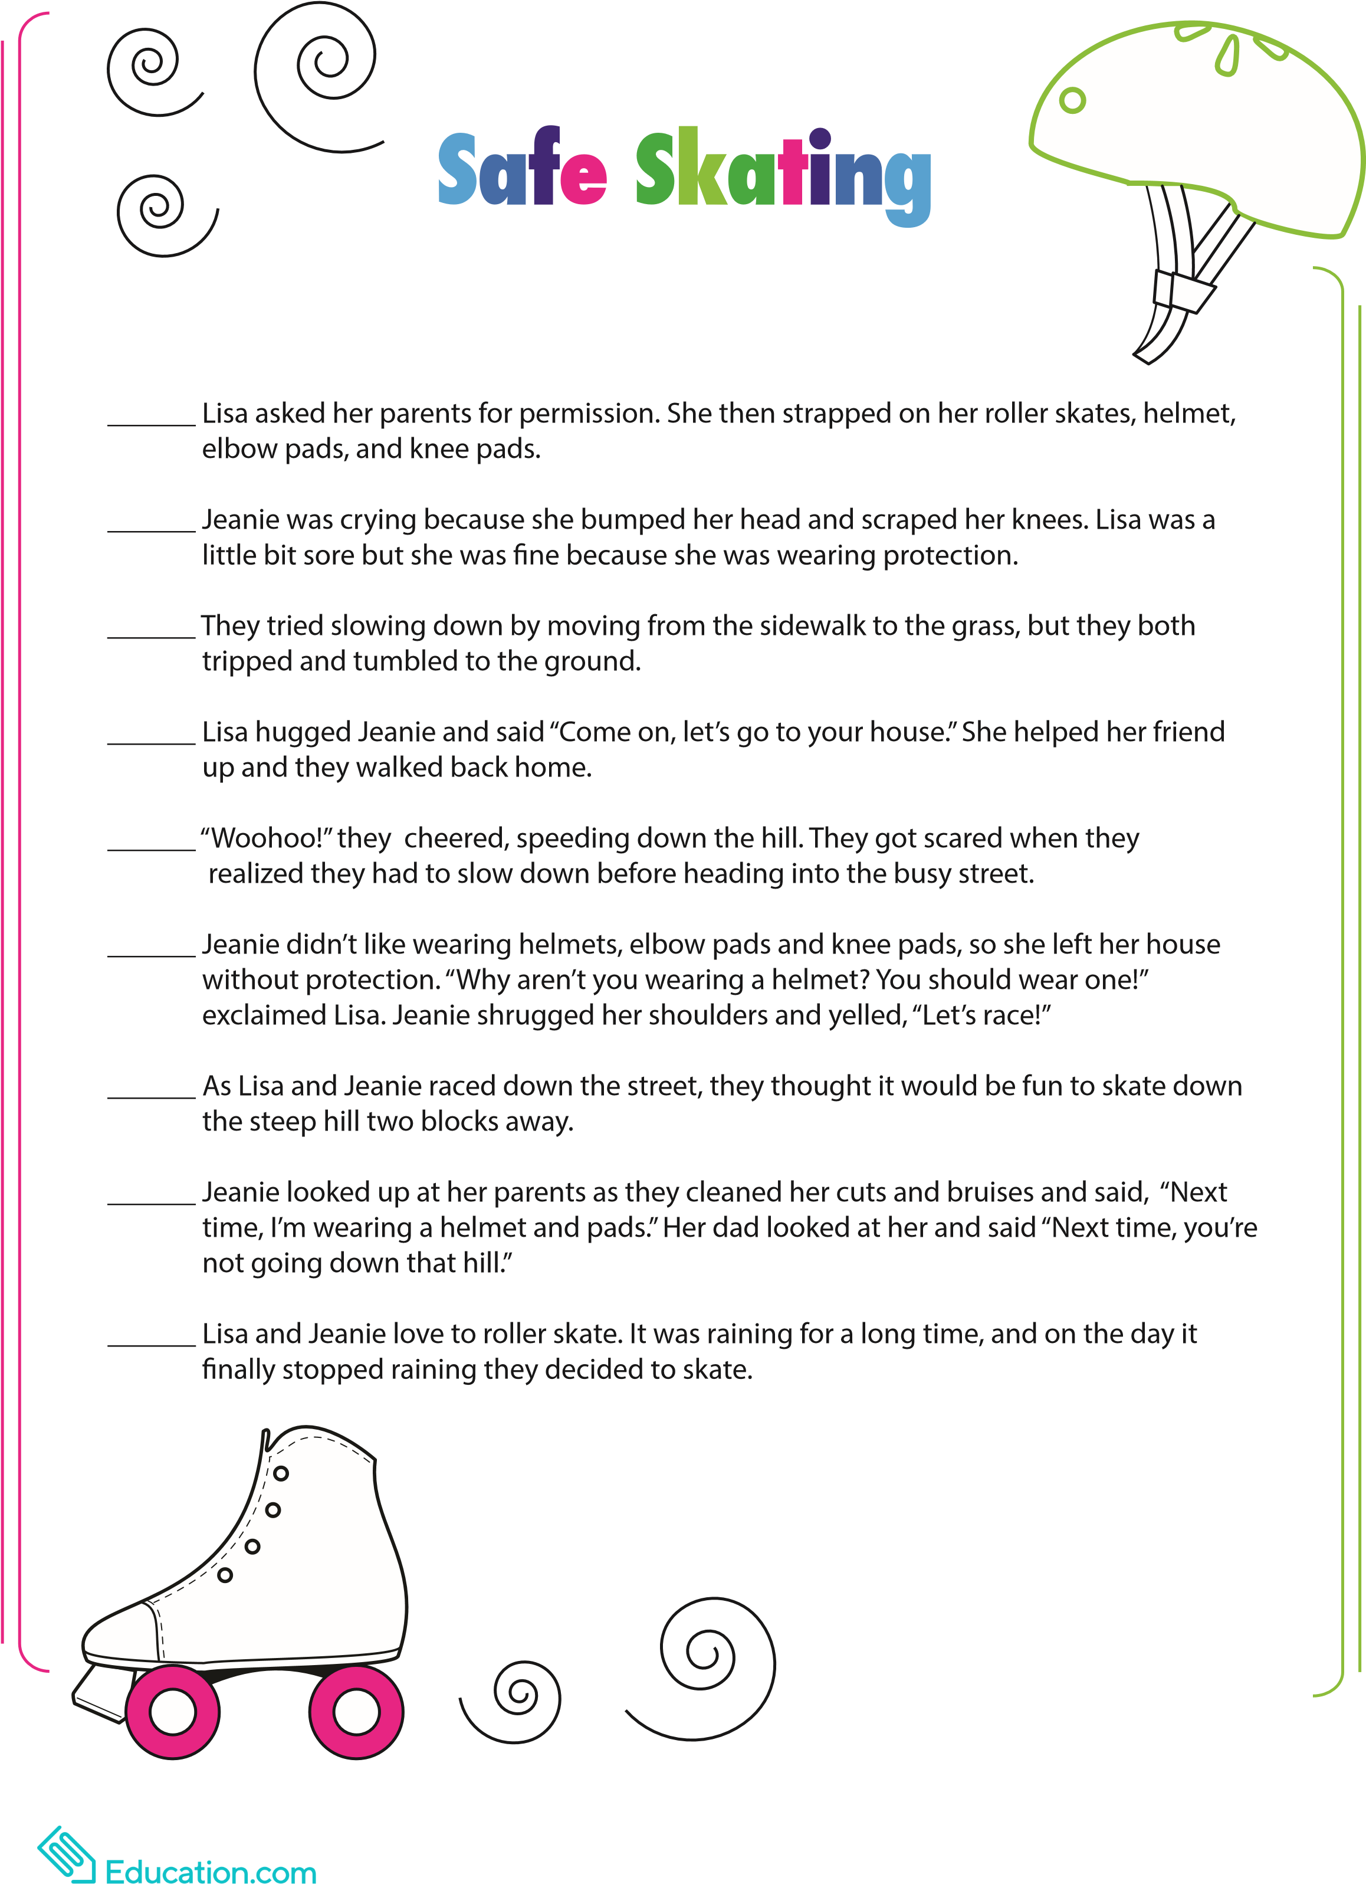
Number the sentences below to put them in the correct order.

