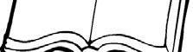
Name Story Map

Setting Characters

Beginning
Middle
E nd
© Katie Byrd

